**IMPLEMENTATION OF 1ST ASSIGNMENT**

1. **STUDENT**

**SOLUTION:**

public static void main(String[] args) {

// TODO code application logic here

Student s1=new Student();

Scanner input=new Scanner(System.in);

char r;

do {

System.out.println("WHICH PROCESS DO YOU WANT TO PERFORM ---\n1) DISPLAY\n2) UPDATE\n3) INPUT");

System.out.print("Select from above (1) OR (2) OR (3) : ");

int res=input.nextInt();

switch(res){

case 1:

s1.Display();

break;

case 2:

s1.Update();

System.out.println("-----------------------------");

System.out.println("---- UPDATED -----");

System.out.println("-----------------------------");

s1.Display();

System.out.println("-----------------------------");

s1.Display();

break;

case 3:

s1.input();

s1.Display();

break;

default:

System.out.println("---------------------------------");

System.out.println(" INVALID ENTRY --- ---- -- -- ");

System.out.println("---------------------------------");

break; }

System.out.print("DO YOU WANT TO PERFORM AGAIN (y | n): ");

r=input.next().charAt(0);

} while (r=='y'); }

**public class Student {**

int res;

char re;

Scanner input=new Scanner(System.in);

String enr_no,name,f_name,address;

private String contact;

int age;

Student(){

name="ahsan";

f_name="Abdul Haq";

address="manora";

age=18;

enr_no="02-131212-049";

}

void setcontact(String c){

this.contact=c;

}

String getcontact(){

return contact;

}

public void input(){

System.out.print("Enter your name: ");

name=input.next();

System.out.print("Enter your father name: ");

f_name=input.next();

System.out.print("Enter your Address: ");

address=input.next();

System.out.print("Enter your age: ");

age=input.nextInt();

System.out.print("Enter your enrollment no: ");

enr_no=input.next();

System.out.print("Enter your contact: ");

contact=input.next();

}

public void Display(){

System.out.println("NAME = "+ name);

System.out.println("Father NAME = "+ f_name);

System.out.println("AGE = "+age);

System.out.println("Address = "+address);

System.out.println("ENROLLMENT NO = "+enr_no);

System.out.println("Contact = "+ contact);

}

void Update(){

do {

System.out.println("What you want to update: ");

System.out.print("1) NAME\n2) FATHER NAME\n3) CONTACT\n4) ADDRESS\n5) AGE\n6) ENROLLMENT NO\n ENTER ------>");

res=input.nextInt();

switch(res){

case 1:

System.out.print("Enter your name: ");

name=input.next();

break;

case 2:

System.out.print("Enter your father name: ");

f_name=input.next();

break;

case 3:

System.out.print("Enter your contact: ");

contact=input.next();

break;

case 4:

System.out.print("Enter your Address: ");

address=input.next();

break;

case 5:

System.out.print("Enter your age: ");

age=input.nextInt();

break;

case 6:

System.out.print("Enter your enrollment no: ");

enr_no=input.next();

break;

default:

System.out.println("----- INVALID ENTRY ------");

break;

}

System.out.println("Do you want to update any other(Y/N): ");

re=input.next().charAt(0);

} while (re=='y');

}

}

**OUTPUT:**

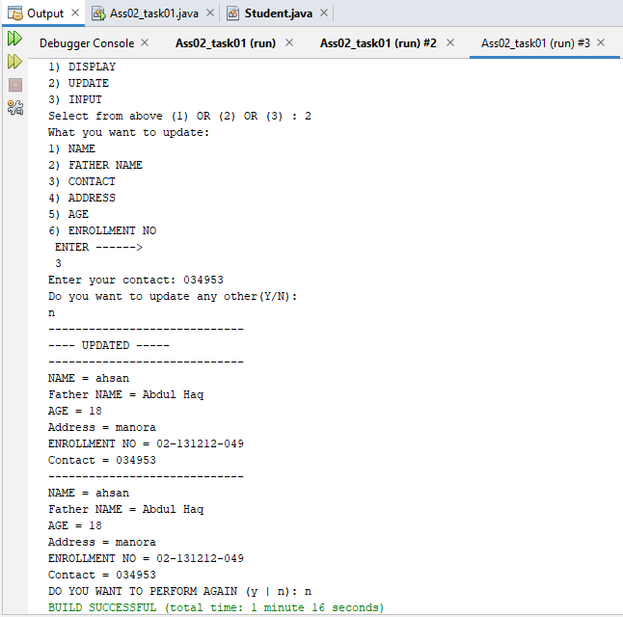

1. **EMPLOYEE**

**SOLUTION:**

public static void main(String[] args) {

// TODO code application logic here

Employee s1=new Employee();

Scanner input=new Scanner(System.in);

char r;

do {

System.out.println("WHICH PROCESS DO YOU WANT TO PERFORM ---\n1) DISPLAY\n2) UPDATE\n3) INPUT\n4) Performance");

System.out.print("Select from above (1) OR (2) OR (3) OR (4) : ");

int res=input.nextInt();

switch(res){

case 1:

s1.Display();

break;

case 2:

s1.Update();

System.out.println("-----------------------------");

System.out.println("---- UPDATED -----");

System.out.println("-----------------------------");

s1.Display();

System.out.println("-----------------------------");

s1.Display();

break;

case 3:

s1.input();

s1.Display();

break;

case 4:

s1.performance();

break;

default:

System.out.println("---------------------------------");

System.out.println(" INVALID ENTRY --- ---- -- -- ");

System.out.println("---------------------------------");

break; }

System.out.print("DO YOU WANT TO PERFORM AGAIN (y | n): ");

r=input.next().charAt(0);

} while (r=='y'); }

}

**public class Employee {**

int res,r;

char re;

Scanner input=new Scanner(System.in);

String name;

int age,grade,salary;

Employee(){

name="ahsan";

age=18;

salary=50000;

grade=17;

}

public void input(){

System.out.print("Enter your name: ");

name=input.next();

System.out.print("Enter your SALARY: ");

salary=input.nextInt();

System.out.print("Enter your age: ");

age=input.nextInt();

System.out.print("Enter your GRADE: ");

grade=input.nextInt();

}

public void Display(){

System.out.println("NAME = "+ name);

System.out.println("SALARY = "+ salary);

System.out.println("AGE = "+age);

System.out.println("GRADE = "+grade);

}

void Update(){

do {

System.out.println("What you want to update: ");

System.out.print("1) NAME\n2) SALARY \n3) AGE\n4) GRADE\n ENTER ------>");

res=input.nextInt();

switch(res){

case 1:

System.out.print("Enter your name: ");

name=input.next();

break;

case 2:

System.out.print("Enter your SALARY: ");

salary=input.nextInt();

break;

case 3:

System.out.print("Enter your age: ");

age=input.nextInt();

break;

case 4:

System.out.print("Enter your GRADE: ");

grade=input.nextInt();

break;

default:

System.out.println("----- INVALID ENTRY ------");

break;

}

System.out.println("Do you want to update any other(Y/N): ");

re=input.next().charAt(0);

} while (re=='y');

}

void performance(){

System.out.print("SELECT THE PERFORMANCE OF EMPLOYEE \n1) GOOD\n2) BAD\n ENTER-----> ");

r=input.nextInt();

switch(r){

case 1:

System.out.println("performance is good");

break;

case 2:

System.out.println("performance is bad");

break;

default:

System.out.println("----- INVALID ENTRY ------");

break;

}

}

}

**OUTPUT:**

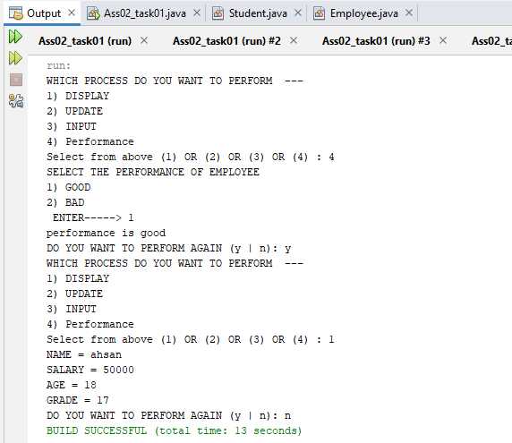

1. **CIRCLE**

**SOLUTION:**

public static void main(String[] args) {

// TODO code application logic here

Scanner input=new Scanner(System.in);

System.out.print("Enter the color of circle: ");

String col=input.next();

Circle c1=new Circle(col);

System.out.print("Enter the radius of circle : ");

double radius=input.nextDouble();

c1.setradius(radius);

c1.Display();

}

**public class Circle {**

String color;

private double radius, perimeter, area;

final double pi = 3.14;

Circle(String color){

this.color=color;

}

void setradius(double r) {

radius = r;

}

double getradius() {

return radius;

}

double getarea() {

area = pi * radius * radius;

return area;

}

double getperimeter() {

perimeter = 2 * pi * radius;

return perimeter;

}

void Display() {

System.out.println("------------------------------------");

System.out.println("----------- CIRCLE DATA----------");

System.out.println("------------------------------------");

System.out.println("COLOUR = "+color);

System.out.println("RADIUS = " + getradius());

System.out.println("AREA = " + getarea());

System.out.println("PERIMETER = " + getperimeter());

System.out.println("------------------------------------");

}

}

**OUTPUT:**

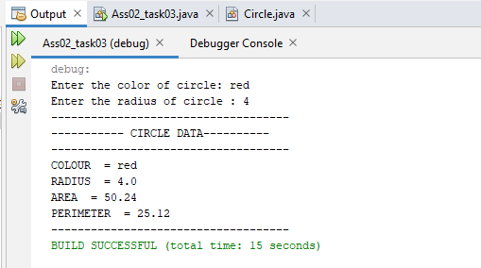

1. **RECTANGLE**

**SOLUTION:**

public static void main(String[] args) {

// TODO code application logic here

Scanner input=new Scanner(System.in);

System.out.print("Enter the color of Rectangle: ");

String col=input.next();

Rectangle c1=new Rectangle(col);

System.out.print("Enter the length of Rectangle : ");

double length=input.nextDouble();

System.out.print("Enter the width of Rectangle : ");

double width=input.nextDouble();

c1.setlength(length);

c1.setwidth(width);

c1.Display();

}

**public class Rectangle {**

String color;

private double length,width, perimeter, area;

final double pi = 3.14;

Rectangle(String color){

this.color=color;

}

void setlength(double l) {

length = l;

}

double getlength() {

return length;

}

void setwidth(double w) {

width = w;

}

double getwidth() {

return width;

}

double getarea() {

area =length*width;

return area;

}

double getperimeter() {

perimeter = 2 *(length+width);

return perimeter;

}

void Display() {

System.out.println("------------------------------------");

System.out.println("----------- Rectangle DATA----------");

System.out.println("------------------------------------");

System.out.println("COLOUR = "+color);

System.out.println("LENGTH = " + getlength());

System.out.println("BREATH = " + getwidth());

System.out.println("AREA = " + getarea());

System.out.println("PERIMETER = " + getperimeter());

System.out.println("------------------------------------");

}

}

**OUTPUT:**

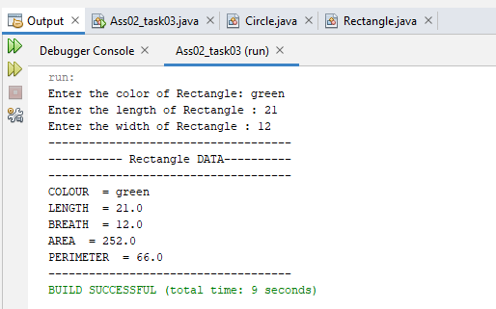

1. **CAR**

**SOLUTION:**

public static void main(String[] args) {

Scanner input = new Scanner(System.in);

Car cs=new Car();

System.out.println("the current state of car ");

System.out.println("1) ON \n2) OFF");

System.out.print("Select from above: ");

int re=input.nextInt();

switch(re){ case 1:

System.out.println("---- CURRENT sTATUS OF cAR -------");

cs.Display();

System.out.print("Do you want to update any part(y/n): ");

char res=input.next().toLowerCase().charAt(0);

if (res=='y') {

System.out.print("Which part Do you want to update: ");

System.out.println("1) horse power \n2) colour \n3) made\n4) Engine type ");

System.out.print("Select from above: ");

int rep=input.nextInt();

switch (rep){

case 1:

cs.ChangeHp();

System.out.println("------------------------------------");

System.out.println("-----UPDATED ---------");

System.out.println("------------------------------------");

cs.Display();

break;

case 2:

cs.ChangeColour(); System.out.println("------------------------------------");

System.out.println("-----UPDATED ---------");

System.out.println("------------------------------------");

cs.Display();

break;

case 3:

cs.Changemade();

System.out.println("------------------------------------");

System.out.println("-----UPDATED ---------");

System.out.println("------------------------------------");

cs.Display();

break;

case 4:

cs.ChangeEngine();

System.out.println("------------------------------------");

System.out.println("-----UPDATED ---------");

System.out.println("------------------------------------");

cs.Display();

break;

default:

System.out.println("------------------------------------");

System.out.println("----- INVALID ENTRY ---------");

System.out.println("------------------------------------");

cs.Display();

break; }

}else {

System.out.println("----PROGRAM TERMINATED----");}

break;

case 2:

System.out.print("Do you want to start the car(y/n): ");

char r=input.next().toLowerCase().charAt(0);

if (r=='y') {

System.out.println("---- CURRENT sTATUS OF cAR -------");

cs.Display();

System.out.print("Do you want to update any part(y/n): ");

char repl=input.next().toLowerCase().charAt(0);

if (repl=='y') {

System.out.print("Which part Do you want to update: ");

System.out.println("1) horse power \n2) colour \n3) made\n4) Engine type ");

System.out.print("Select from above: ");

int rep=input.nextInt();

switch (rep){ case 1:

cs.ChangeHp();

System.out.println("------------------------------------");

System.out.println("-----UPDATED ---------");

System.out.println("------------------------------------");

cs.Display();

break;

case 2:

cs.ChangeColour();

System.out.println("------------------------------------");

System.out.println("-----UPDATED ---------");

System.out.println("------------------------------------");

cs.Display();

break;

case 3:

cs.Changemade();

System.out.println("------------------------------------");

System.out.println("-----UPDATED ---------");

System.out.println("------------------------------------");

cs.Display();

break;

case 4:

cs.ChangeEngine();

System.out.println("------------------------------------");

System.out.println("-----UPDATED ---------");

System.out.println("------------------------------------");

cs.Display();

break;

default:

System.out.println("------------------------------------");

System.out.println("----- INVALID ENTRY ---------");

System.out.println("------------------------------------");

cs.Display();

break; }

}else {

System.out.println("----PROGRAM TERMINATED----"); }}

else {

System.out.println("----PROGRAM TERMINATED----");} break;

default:

System.out.println("------------------------------------");

System.out.println("----- INVALID ENTRY ---------");

System.out.println("------------------------------------"); break;}

**public class Car{**

Scanner input = new Scanner(System.in);

String hp = "139";

String colour="black";

String made="america";

String e_type="1.8L 4-Cylinder";

void Display(){

System.out.println("------------------------------------");

System.out.println(" HORSE POWER OF CAR = "+ hp);

System.out.println("COLOUR OF CAR = "+ colour);

System.out.println("MADE BY = "+ made);

System.out.println("ENGINE TYPE OF CAR = "+ e_type);

System.out.println("------------------------------------");}

void ChangeHp(){

System.out.print("Enter Horse power: ");

hp=input.next();}

void ChangeColour(){

System.out.print("Enter COLOUR: ");

colour=input.next();}

void Changemade(){

System.out.print(" MADE BY: ");

made=input.next();}

void ChangeEngine(){

System.out.print("Enter ENGINE TYPE: ");

e_type=input.next();}}

**Output:**

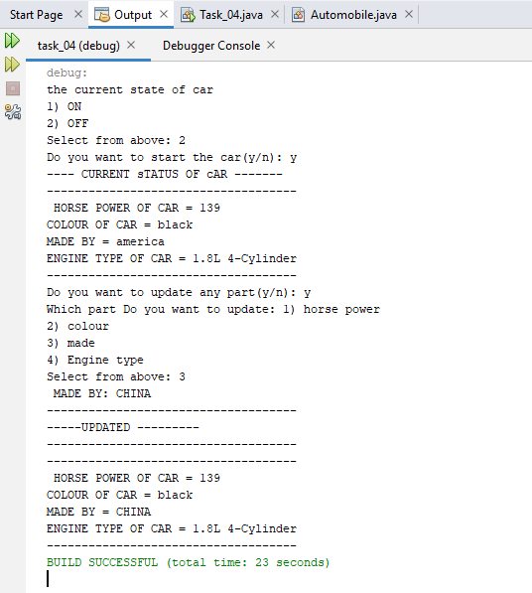

1. **COMPUTER**

**SOLUTION:**

public static void main(String[] args) {

// TODO code application logic here

Scanner input=new Scanner(System.in);

Computer s1=new Computer();

s1.setram(4);

s1.setrom(128);

char r;

do {

System.out.println("WHICH PROCESS DO YOU WANT TO PERFORM ---\n1) DISPLAY\n2) UPDATE\n3) INPUT");

System.out.print("Select from above (1) OR (2) OR (3) : ");

int res=input.nextInt();

switch(res){

case 1:

s1.Display();

break;

case 2:

s1.Update();

System.out.println("-----------------------------");

System.out.println("---- UPDATED -----");

System.out.println("-----------------------------");

s1.Display();

System.out.println("-----------------------------");

break;

case 3:

s1.input();

s1.Display();

break;

default:

System.out.println("---------------------------------");

System.out.println(" INVALID ENTRY --- ---- -- -- ");

System.out.println("---------------------------------");

break; }

System.out.print("DO YOU WANT TO PERFORM AGAIN (y | n): ");

r=input.next().charAt(0);

} while (r=='y'); }

**public class Computer {**

Scanner input=new Scanner(System.in);

String company;

int price,res;

char re;

private int ram,rom;

Computer(){

this.company="hp";

this.price=20000;

this.ram=0;

this.rom=0;

}

void setram(int r){

this.ram=r;

}

void setrom(int r){

this.rom=r;

}

int getram(){

return ram;

}

int getrom(){

return rom;

}

void Display() {

System.out.println("------------------------------------");

System.out.println("----------- Computer DATA----------");

System.out.println("------------------------------------");

System.out.println("COMPANY = "+company);

System.out.println("PRICE = " + price);

System.out.println("RAM = " + ram);

System.out.println("ROM = " + rom);

}

public void input(){

System.out.print("Enter company name: ");

company=input.next();

System.out.print("Enter price: ");

price=input.nextInt();

System.out.print("Enter ram: ");

ram=input.nextInt();

System.out.print("Enter rom: ");

rom=input.nextInt();

}

void Update(){

do {

System.out.println("What you want to update: ");

System.out.print("1) COMPANY\n2) PRICE\n3) RAM\n4) ROM\n ENTER ------>");

res=input.nextInt();

switch(res){

case 1:

System.out.print("Enter company name: ");

company=input.next();

break;

case 2:

System.out.print("Enter price: ");

price=input.nextInt();

break;

case 3:

System.out.print("Enter ram: ");

ram=input.nextInt();

break;

case 4:

System.out.print("Enter rom: ");

rom=input.nextInt();

break;

default:

System.out.println("----- INVALID ENTRY ------");

break;

}

System.out.println("Do you want to update any other(Y/N): ");

re=input.next().charAt(0);

} while (re=='y');

}

}

**OUTPUT:**

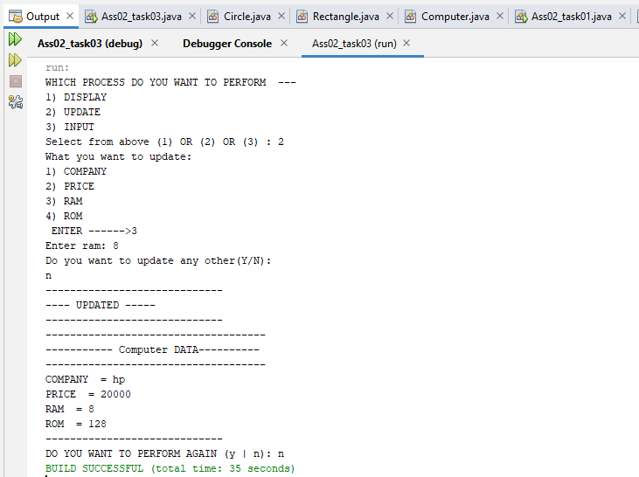

1. **AC**

**SOLUTION:**

public static void main(String[] args) {

// TODO code application logic here

Scanner sc = new Scanner(System.in);

AC ac = new AC();

char res;

ac.on();}

}

**public class AC {**

Scanner sc = new Scanner(System.in);

String Companyname;

String model;

String size;

int gruntee;

int makeyear;

public AC(String Companyname, String model, String size, int gruntee, int makeyear) {

this.Companyname = Companyname;

this.model = model;

this.size = size;

this.gruntee = gruntee;

this.makeyear = makeyear; }

void Input() {

String company, model, size;

int gruntee, make;

System.out.print("Enter The Company Of Your AC : ");

company = sc.nextLine();

Companyname = company;

System.out.print("Enter The Model Of Your AC : ");

model = sc.nextLine();

this.model = model;

System.out.print("Enter The Size Of Your AC : ");

size = sc.nextLine();

this.size = size;

System.out.print("Enter The Gruntee Of Your AC : ");

gruntee = Integer.parseInt(sc.nextLine());

this.gruntee = gruntee;

System.out.print("Enter The Make Year Of Your AC : ");

make = Integer.parseInt(sc.nextLine());

this.makeyear = make;

} public AC() {

Companyname = "Intel";

model = "X225 Series";

size = "Core 2 Due , 64 Bit System";

gruntee = 4;

makeyear = 2019;

} void display() {

System.out.println("-------------------------------------------------------");

System.out.println("Company Name Of AC = " + Companyname);

System.out.println(" Model Of AC = " + model);

System.out.println("Size Of AC = " + size);

System.out.println("Gruntee Of AC = " + gruntee + " Year");

System.out.println("Make Year Of AC = " + makeyear + " ");

System.out.println("-------------------------------------------------------");

} void on() {

char res;

do {

System.out.print("Do You Want To Start AC ( y / n ) : ");

res = sc.nextLine().charAt(0);

if (res == 'y') {

do {

System.out.println("Please Select Options \n 1) Input AC Details\n 2) Display AC Details\n 3) Change Coolng \n 4) Stop AC \n 5) Exit");

System.out.print("Enter : ");

res = sc.nextLine().charAt(0);

if (res == '1') {

Input();

} else if (res == '2') { display();

} else if (res == '3') {

Changecooling();

} else if (res == '4') {

off(); break;

} else if (res == '5') { break; }

else {

System.out.println("|------------------------------------------------------|");

System.out.println("|------------------PLease Choose Correct Option--------|");

System.out.println("|------------------------------------------------------|");}

} while (res != 1 || res != 2 || res != 3 || res != 4 || res != 5);

} else if (res == 'n') { break; }

else {

System.out.println("|------------------------------------------------------|");

System.out.println("|--------PLease Choose Correct Option ( y / n )--------|");

System.out.println("|------------------------------------------------------|");}

} while (res != 'y' || res != 'n');}

int colling = 0;

void Changecooling() {

char res;

do {

System.out.println("PLease Select !\n 1) Increase Colling \n 2) Decrease Colling \n 3) GOTO \n 4) Exit");

System.out.print("Enter : ");

res = sc.nextLine().charAt(0);

if (res == '1') {

if (colling >= 0 && colling <= 9) {

System.out.println("Previous Colling = " + colling);

colling++;

System.out.println("Updated Colling = " + colling);

} else {

System.out.println("Colling Can;t Exceeded By 10 !!!!");}

} else if (res == '2') {

if (colling >= 1) {

System.out.println("Previous Colling = " + colling);

colling--;

System.out.println("Updated Colling = " + colling);

} else {

System.out.println("Colling Value Can't Be Negative !!!");

} } else if (res == '3') {

System.out.print("Enter Value You Want To Set Your AC : ");

System.out.println("\nPrevious Colling : " + colling);

System.out.print("Enter : ");

colling = sc.nextInt();

sc.nextLine();

System.out.println("Updated Colling Colling : " + colling);

} else if (res == '4') {

break;

} else {

System.out.println("|------------------------------------------------------|");

System.out.println("|--------PLease Choose Correct Option------------------|");

System.out.println("|------------------------------------------------------|"); }

} while (res != 1 || res != 2 || res != 3); }

void off() {

System.out.println("!!!!!!!!!!!!!!!!!!!!!!!!!!!!!!!!!!!!!!!!!!!!!!!!!!!!");

System.out.println("!!!!!!!!!!The AC Has Been O F F !!!!!!!!!!!!!!!!!!");

System.out.println("!!!!!!!!!!!!!!!!!!!!!!!!!!!!!!!!!!!!!!!!!!!!!!!!!!!!");}

}

**OUTPUT:**

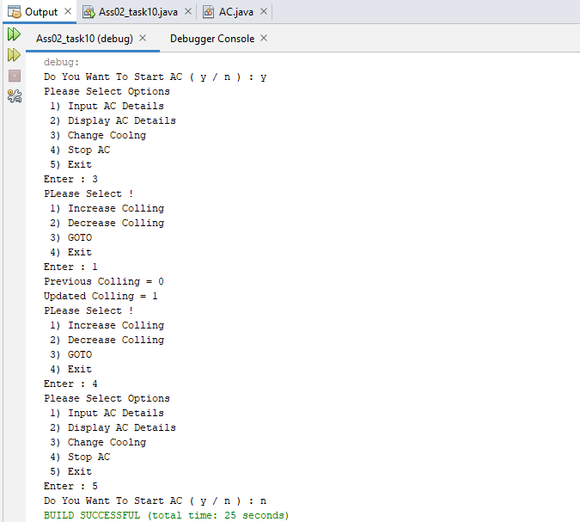

1. **LCD**

**SOLUTION:**

public static void main(String[] args) {

// TODO code application logic here

Scanner input=new Scanner(System.in);

Lcd s1=new Lcd();

char r;

do {

System.out.println("WHICH PROCESS DO YOU WANT TO PERFORM ---\n1) DISPLAY\n2) UPDATE\n3) INPUT\n4) VOLUME INCREASE\n5) VOLUME DECREASE");

System.out.print("Select from above (1) OR (2) OR (3) OR (4) OR (5) : ");

int res=input.nextInt();

switch(res){

case 1:

System.out.println("-----------------------------");

s1.Display();

System.out.println("-----------------------------");

break;

case 2:

s1.Update();

System.out.println("-----------------------------");

System.out.println("---- UPDATED -----");

System.out.println("-----------------------------");

s1.Display();

System.out.println("-----------------------------");

break;

case 3:

s1.input();

s1.Display();

break;

case 4:

s1.volinc();

s1.Display();

break;

case 5:

s1.voldec();

s1.Display();

break;

default:

System.out.println("---------------------------------");

System.out.println(" INVALID ENTRY --- ---- -- -- ");

System.out.println("---------------------------------");

break; }

System.out.print("DO YOU WANT TO PERFORM AGAIN (y | n): ");

r=input.next().charAt(0);

} while (r=='y');

}

**public class Lcd {**

Scanner input = new Scanner(System.in);

String company;

char re;

int size, guarentee, price, res,volume=23;// default volume

Lcd() {

this.company = "dell";

this.size = 32;

this.guarentee = 5;

this.price = 32000;

}

void volinc(){

volume++;

}

void voldec(){

volume--;

}

void Display() {

System.out.println("COMPANY = " + company);

System.out.println("SIZE = " + size);

System.out.println("PRICE = " + price);

System.out.println("GUARENTEE = " + guarentee + " year");

System.out.println("VOLUME = " + volume);

}

void input() {

System.out.print("enter company : ");

company = input.next();

System.out.print("enter size : ");

size = input.nextInt();

System.out.print("enter price : ");

price = input.nextInt();

System.out.print("enter guarentee : ");

guarentee = input.nextInt();

}

void Update() {

do {

System.out.println("What you want to update: ");

System.out.print("1) COMPANY\n2) SIZE\n3) PRICE\n4) GUARENTEE\n ENTER ------>");

res = input.nextInt();

switch (res) {

case 1:

System.out.print("enter company : ");

company = input.next();

break;

case 2:

System.out.print("enter size : ");

size = input.nextInt();

break;

case 3:

System.out.print("enter price : ");

price = input.nextInt();

break;

case 4:

System.out.print("enter guarentee : ");

guarentee = input.nextInt();

break;

default:

System.out.println("----- INVALID ENTRY ------");

break;

}

System.out.println("Do you want to update any other(Y/N): ");

re = input.next().charAt(0);

} while (re == 'y');}}

**OUTPUT:**

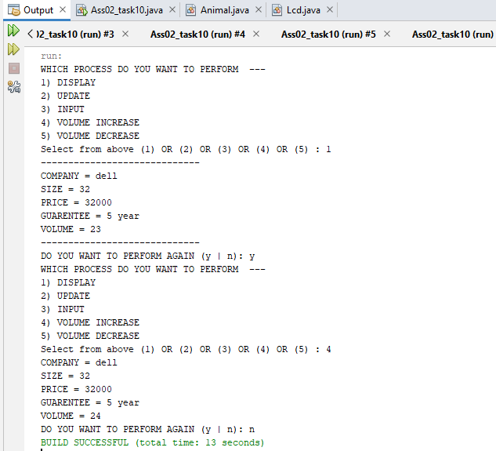

1. **MOBILE**

**SOLUTION:**

public static void main(String[] args) {

// TODO code application logic here

Scanner input=new Scanner(System.in);

Mobile1 s1=new Mobile1();

char r;

do {

System.out.println("WHICH PROCESS DO YOU WANT TO PERFORM ---\n1) DISPLAY\n2) UPDATE\n3) INPUT");

System.out.print("Select from above (1) OR (2) OR (3) : ");

int res=input.nextInt();

switch(res){

case 1:

s1.Display();

break;

case 2:

s1.Update();

System.out.println("-----------------------------");

System.out.println("---- UPDATED -----");

System.out.println("-----------------------------");

s1.Display();

System.out.println("-----------------------------");

break;

case 3:

s1.input();

s1.Display();

break;

default:

System.out.println("---------------------------------");

System.out.println(" INVALID ENTRY --- ---- -- -- ");

System.out.println("---------------------------------");

break; }

System.out.print("DO YOU WANT TO PERFORM AGAIN (y | n): ");

r=input.next().charAt(0);

} while (r=='y'); }

**public class Mobile1 {**

Scanner input=new Scanner(System.in);

String company;

int price,res;

double screen;

char re;

private int imei;

Mobile1(){

this.company="oppo";

this.price=20000;

this.screen=6.2;

this.imei=0;

}

public void setimei(int i){

this.imei=i;

}

int getimei(){

return imei;

}

void Display() {

System.out.println("------------------------------------");

System.out.println("----------- MOBILE INFORMATION----------");

System.out.println("------------------------------------");

System.out.println("COMPANY = "+company);

System.out.println("PRICE = " + price);

System.out.println("SCREEN = " + screen);

System.out.println("IMEI = " + getimei());

}

public void input(){

System.out.print("Enter company name: ");

company=input.next();

System.out.print("Enter price: ");

price=input.nextInt();

System.out.print("Enter ram: ");

screen=input.nextDouble();

}

void Update(){

do {

System.out.println("What you want to update: ");

System.out.print("1) COMPANY\n2) PRICE\n3) Screen\n4) Imei\n ENTER ------>");

res=input.nextInt();

switch(res){

case 1:

System.out.print("Enter company name: ");

company=input.next();

break;

case 2:

System.out.print("Enter price: ");

price=input.nextInt();

break;

case 3:

System.out.print("Enter SCREEN SIZE: ");

screen=input.nextDouble();

break;

case 4:

System.out.print("Enter IMEI no: ");

imei=input.nextInt();

break;

default:

System.out.println("----- INVALID ENTRY ------");

break;

}

System.out.println("Do you want to update any other(Y/N): ");

re=input.next().charAt(0);

} while (re=='y');

}

}

**OUTPUT:**

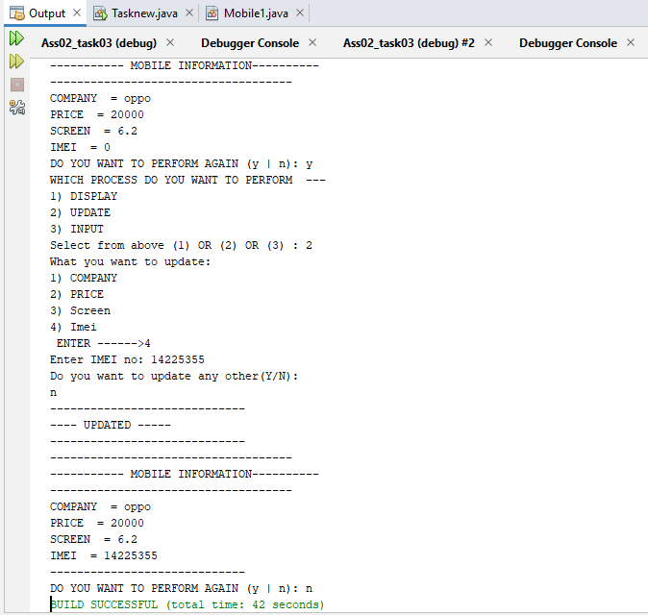

1. **ANIMAL**

**SOLUTION:**

public static void main(String[] args) {

// TODO code application logic here

Scanner input=new Scanner(System.in);

Animal s1=new Animal();

s1.setname("suzi");

s1.setbreed("german");

s1.settype("medium");

char r;

do {

System.out.println("WHICH PROCESS DO YOU WANT TO PERFORM ---\n1) DISPLAY\n2) UPDATE\n3) INPUT");

System.out.print("Select from above (1) OR (2) OR (3) : ");

int res=input.nextInt();

switch(res){

case 1:

System.out.println("-----------------------------");

s1.Display();

System.out.println("-----------------------------");

break;

case 2:

s1.Update();

System.out.println("-----------------------------");

System.out.println("---- UPDATED -----");

System.out.println("-----------------------------");

s1.Display();

System.out.println("-----------------------------");

break;

case 3:

s1.input();

s1.Display();

break;

default:

System.out.println("---------------------------------");

System.out.println(" INVALID ENTRY --- ---- -- -- ");

System.out.println("---------------------------------");

break; }

System.out.print("DO YOU WANT TO PERFORM AGAIN (y | n): ");

r=input.next().charAt(0);

} while (r=='y');

}

**public class Animal {**

Scanner input = new Scanner(System.in);

String color;

char re;

int age, res;

private String type, name, breed;

Animal(){

this.color="black";

this.age=5;

}

void setname(String n){

this.name=n;

}

void settype(String t){

this.type=t;

}

void setbreed(String b){

this.breed=b;

}

String getname(){

return name;

}

String getbreed(){

return breed;

}

String gettype(){

return type;

}

void Display() {

System.out.println("NAME = " + getname());

System.out.println("BREED = " + getbreed());

System.out.println("TYPE = " + gettype());

System.out.println("COLOUR = " + color);

System.out.println("AGE = " + age);

}

void input() {

System.out.print("enter name : ");

name = input.next();

System.out.print("enter breed : ");

breed = input.next();

System.out.print("enter type : ");

type = input.next();

System.out.print("enter color : ");

color = input.next();

System.out.print("enter age : ");

age = input.nextInt();

}

void Update() {

do {

System.out.println("What you want to update: ");

System.out.print("1) NAME\n2) BREED\n3) TYPE\n4) COLOUR\n5) AGE\n ENTER ------>");

res = input.nextInt();

switch (res) {

case 1:

System.out.print("Enter your name: ");

name = input.next();

break;

case 2:

System.out.print("enter breed : ");

breed = input.next();

break;

case 3:

System.out.print("enter type : ");

type = input.next();

break;

case 4:

System.out.print("enter color : ");

color = input.next();

break;

case 5:

System.out.print("Enter your age: ");

age = input.nextInt();

break;

default:

System.out.println("----- INVALID ENTRY ------");

break;

}

System.out.println("Do you want to update any other(Y/N): ");

re = input.next().charAt(0);

} while (re == 'y');

}

}

**OUTPUT:**

